Curriculum Vitae
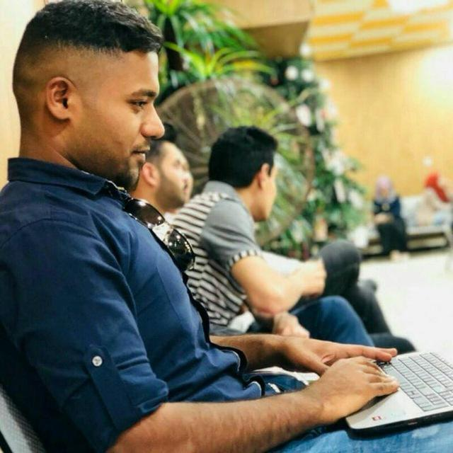

Sallah Saad Mahdi |  |  | Name
Mahawil/Babil/Iraq |  |  | Home Address
7/4/1996 | Birth Date | Mahawil/Babil | Place of Birth
Male | Gender | single | Marital status
muslim | Religion | Iraqi | Nationality

information technology collage | College or institute | University of babylon | University Name
2019 | Graduation year | Information networks and computer Sciences | Specialization
Information networks and computer Sciences |  |  | Specialty

 | +9647831360943 | Phone number
Saadsaleh353@gmail.com |  | E.MAIL

HTML       CSS       ASP.NET       SQL Database       Photoshop CC       lllstarator       Word       PowerPoint       Excel      |  |  |  | Skills
 |  |  |  | Experiences
Writing | Reading | Talk | Language | Languages
good | good | I do not speak fluently | English | Languages
good | good | good | Arabic | Languages
 |  |  | Other language | Languages

